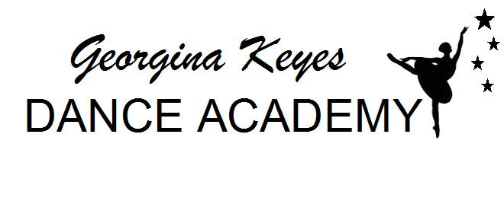

NEW DANCER ENROLMENT FORM
Name: ..............................................................................................................

Address: ..............................................................................................................

DOB:

Any medical ..............................................................................................................
conditions/allergies:

Emergency
contact name: ..............................................................................................................

Emergency
contact number: ...............................................................................................................

Email address: ...............................................................................................................

Please tick the following boxes and sign below to confirm your understanding:

- I consent to pictures being taken of my child during classes or performances and being used for promotional purposes on the GKDA website/facebook/twitter and posters/leaflets etc
- I understand that overdue fees may lead to my child being asked to leave the academy.
- I understand that if my child decides not to carry on with lessons no refund on that term’s tuition will be given

Signed ................................. Date ......................................
Print Name .................................

